Contents

１ Evidence for endpoint protection 2

２ Evidence for getEmployees endpoint output through swagger 3

３ Evidence for getEmployee endpoint output through swagger 4

４ Evidence for saveEmployee endpoint output through swagger 5

５ Evidence for deleteEmployee endpoint output through swagger 7

６ Evidence for updateEmployee endpoint output through swagger 8

７ Evidence for getPaginatedEmployees endpoint output through swagger 10

８ Evidence for Employee Not Found in case of getEmployee endpoint 11

９ Evidence for Employee Not Found in case of deleteEmployee endpoin 12

１０ Evidence for Employee Not Found in case of updateEmployee endpoint 13

１１ Evidence for Caching 14

# Evidence for endpoint protection

Before Login:

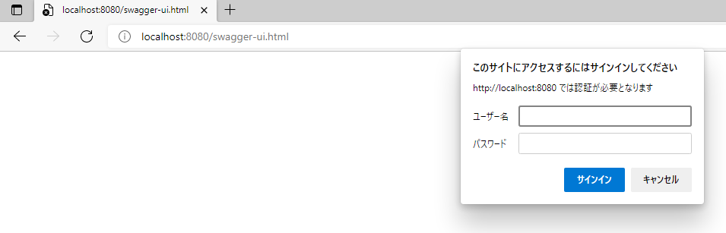

After Login:

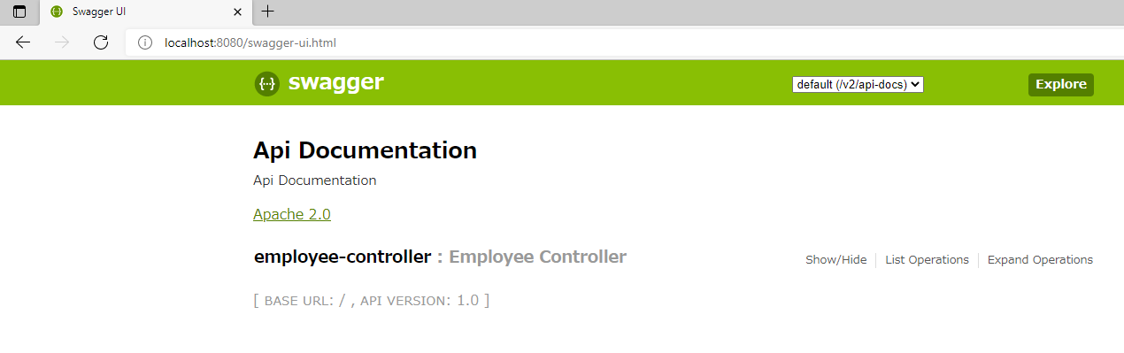

# Evidence for getEmployees endpoint output through swagger

Swagger-UI :

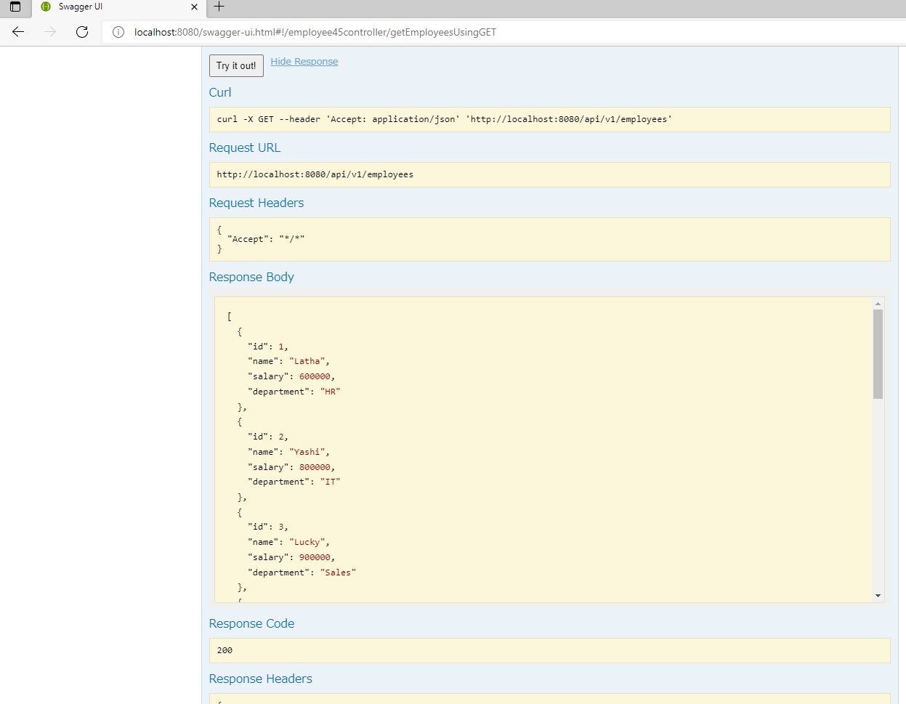

H2 Console :

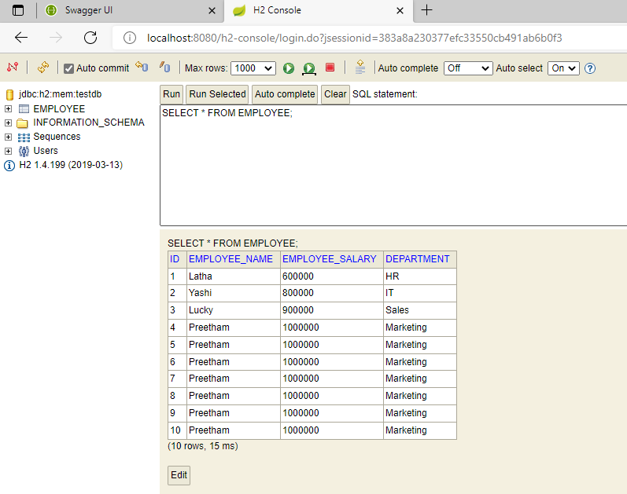

# Evidence for getEmployee endpoint output through swagger

Swagger- UI getEmployee endpoint result for employee 2:

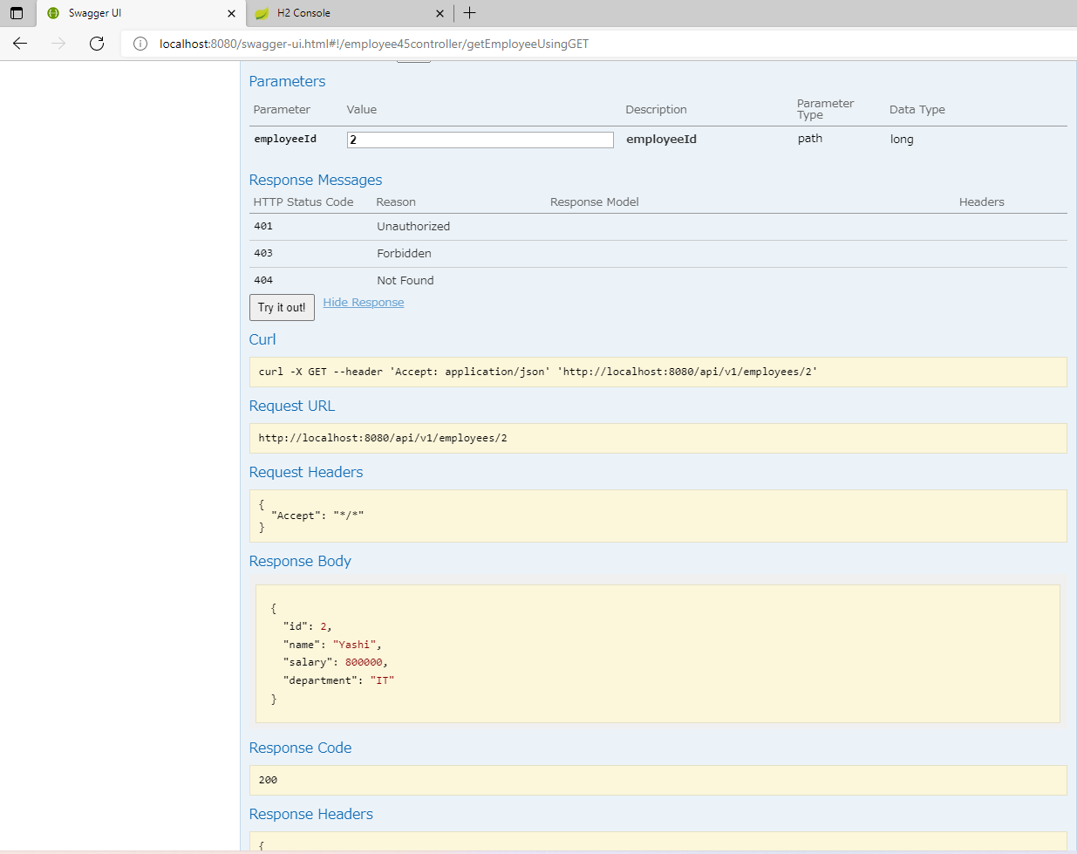

H2 Console :



# Evidence for saveEmployee endpoint output through swagger

H2 Console before saving new employee:



Swagger- UI saveEmployee endpoint result saving new employee :

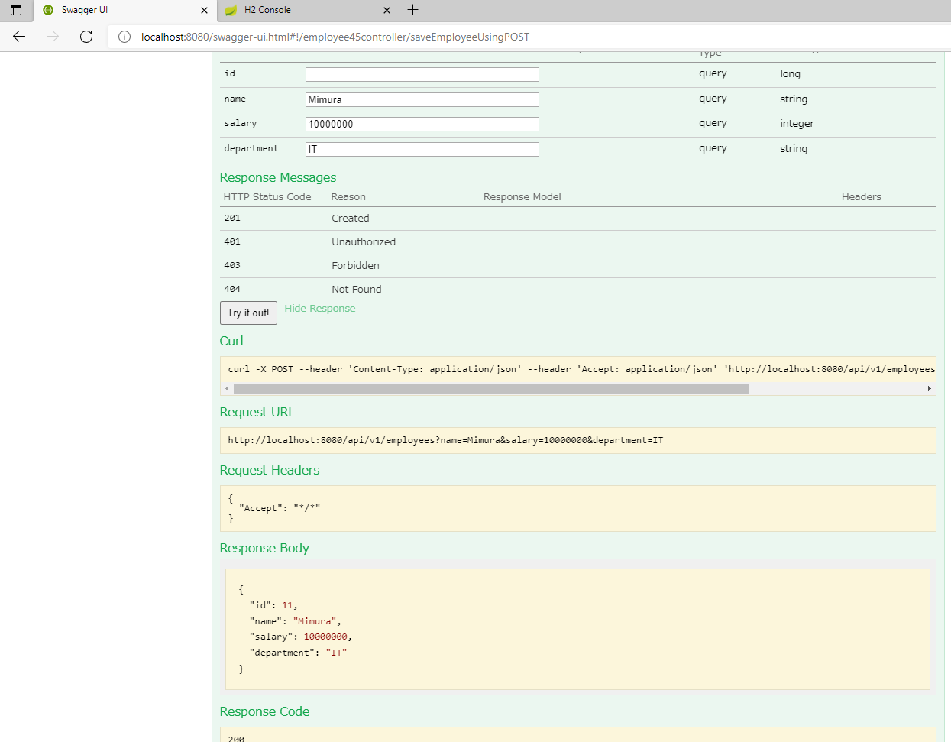

H2 Console after saving new employee:

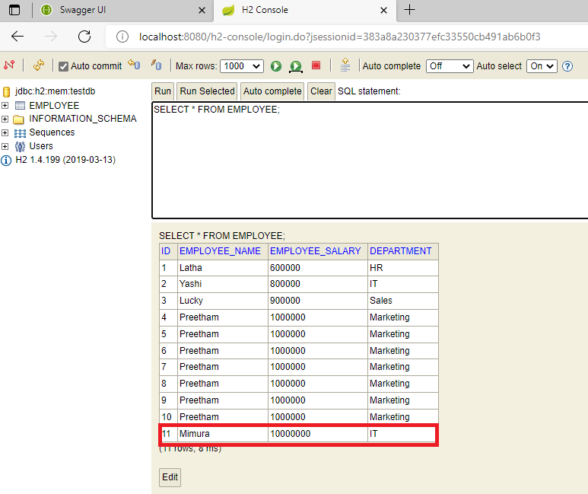

Swagger UI getEmployees endpoint result after saving operation :

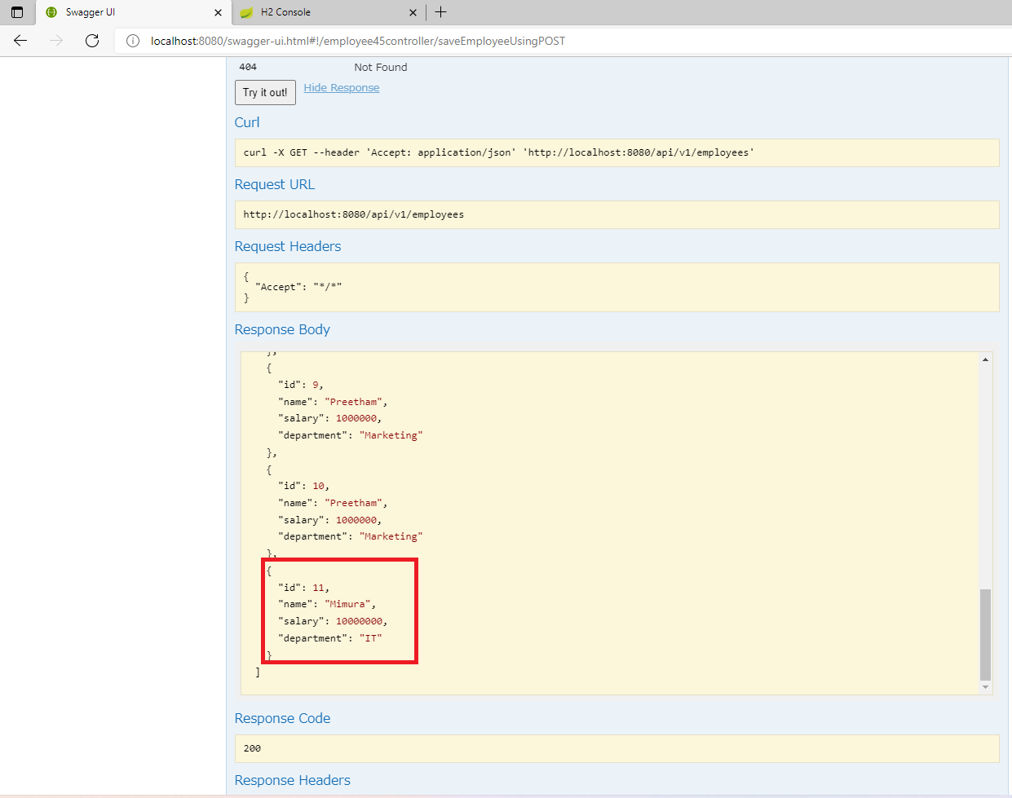

# Evidence for deleteEmployee endpoint output through swagger

Swagger UI deleteEmployee endpoint result for employee 10:

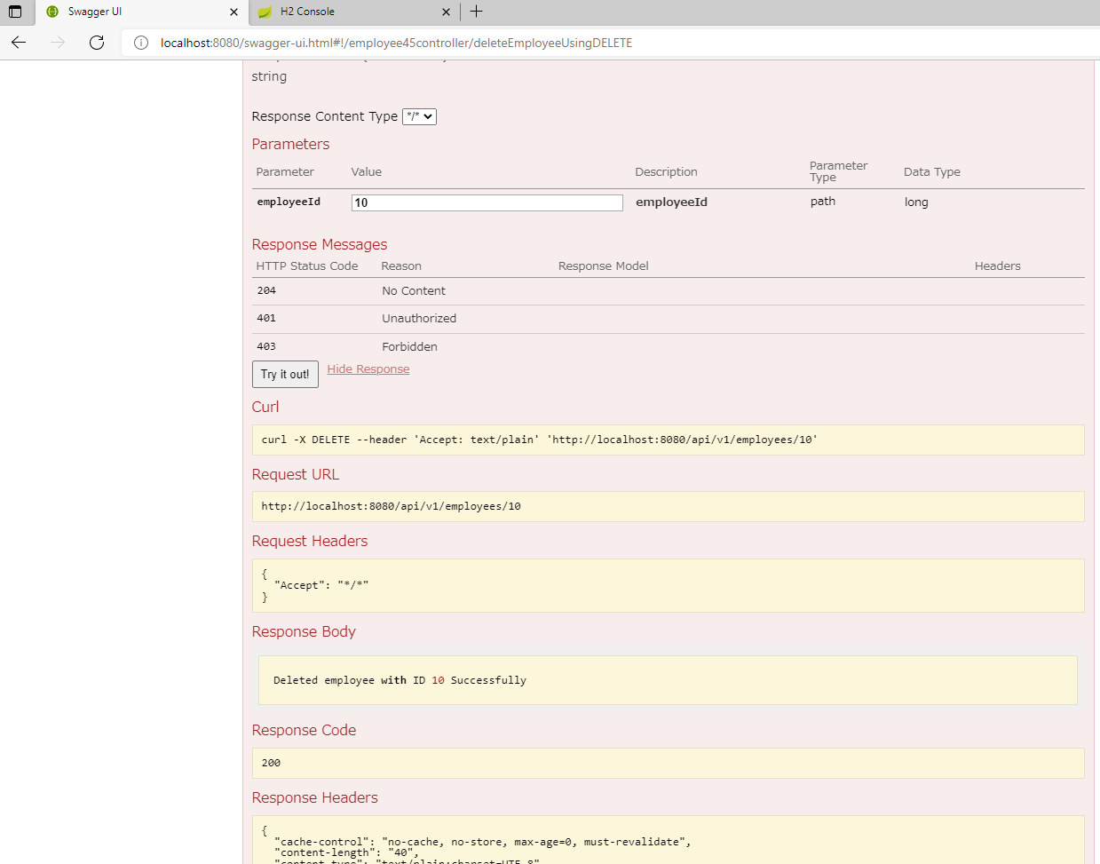

Swagger UI getEmployees endpoint result after deleting employee 10 :

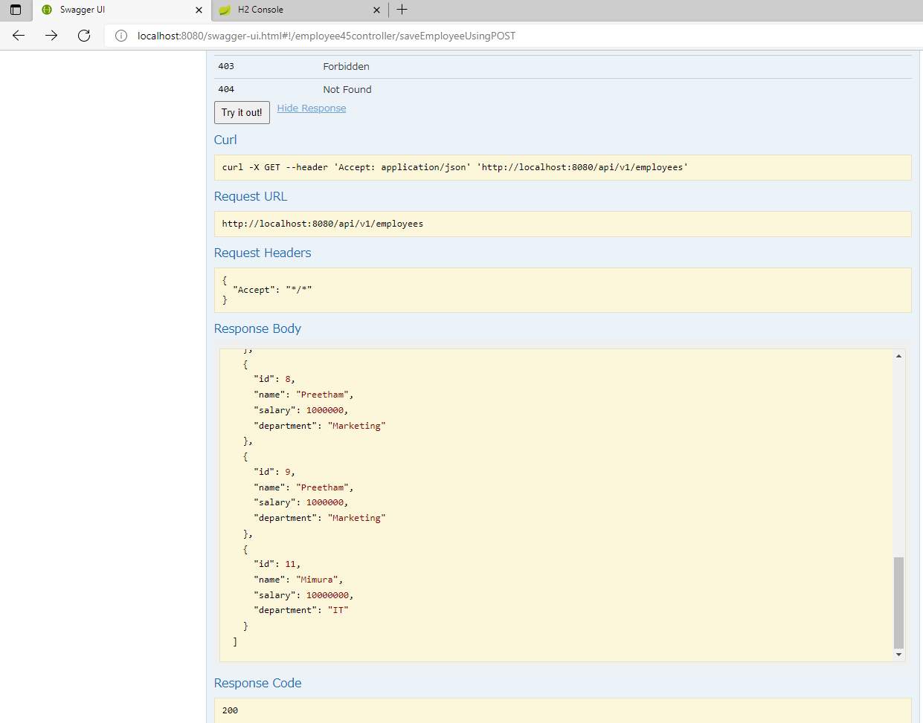

H2 Console after deleting employee ID 10:

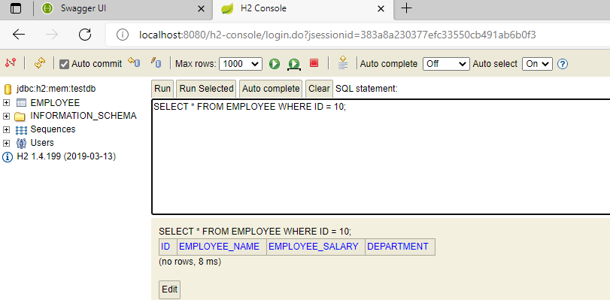

# Evidence for updateEmployee endpoint output through swagger

H2 Console before updating employee 1 :

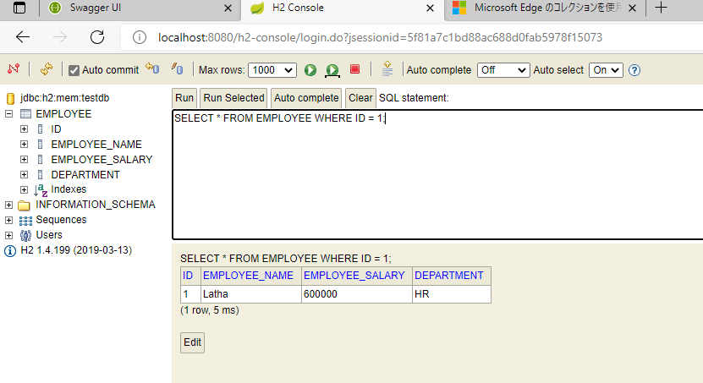

Swagger UI updateEmployee endpoint result after updating employee 1 department to IT:

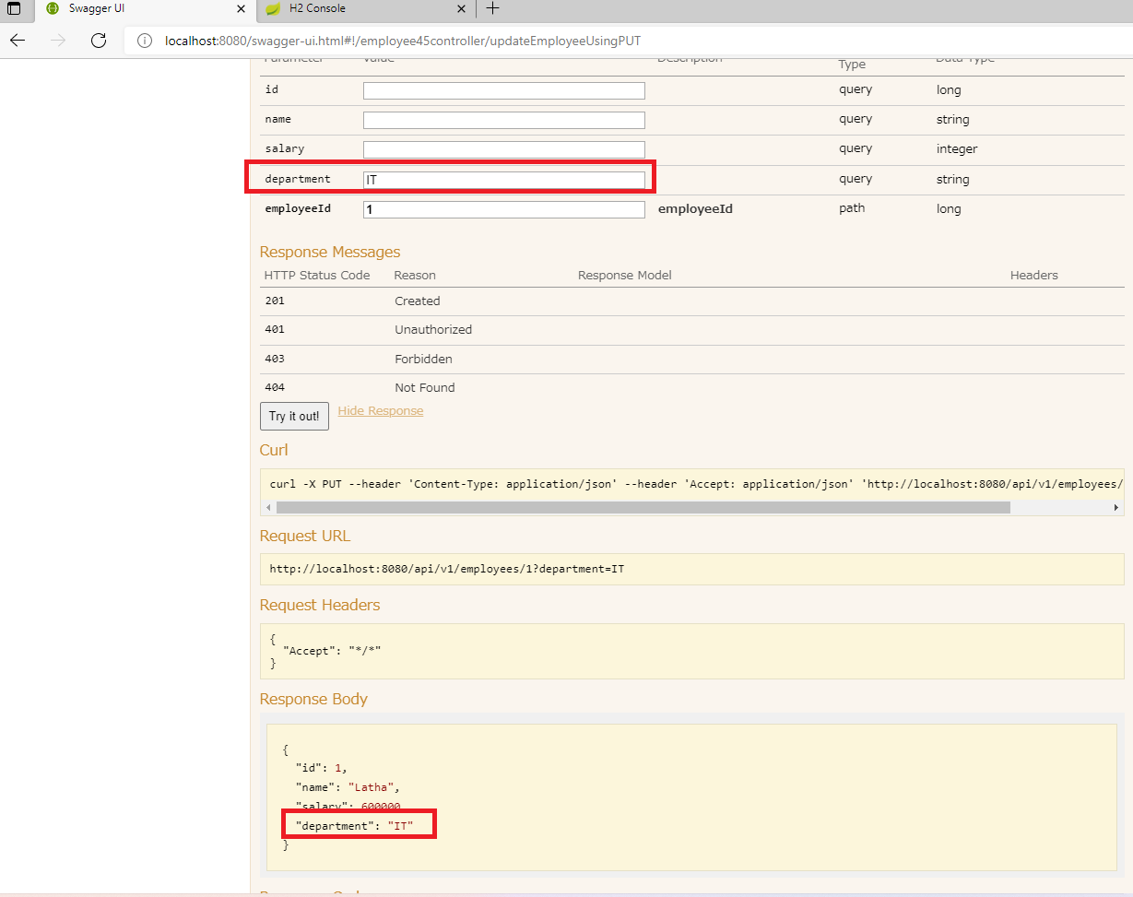

Swagger UI getEmployee endpoint result after updating employee 1 department to IT:

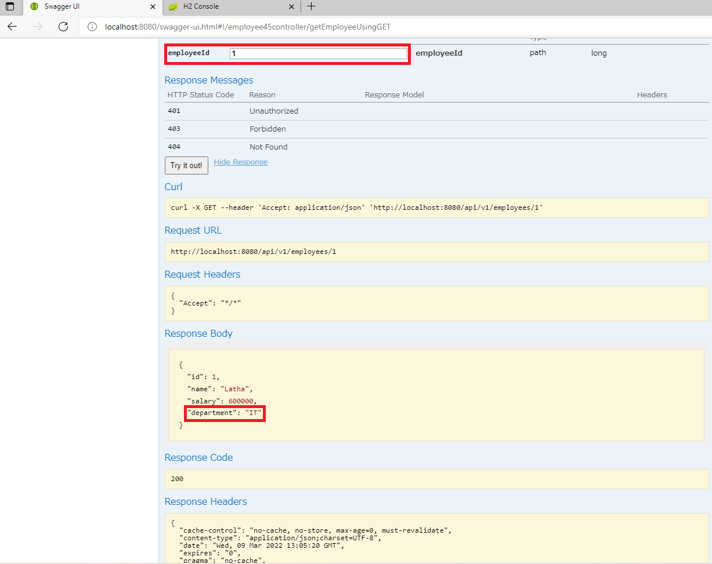

H2 Console after update :

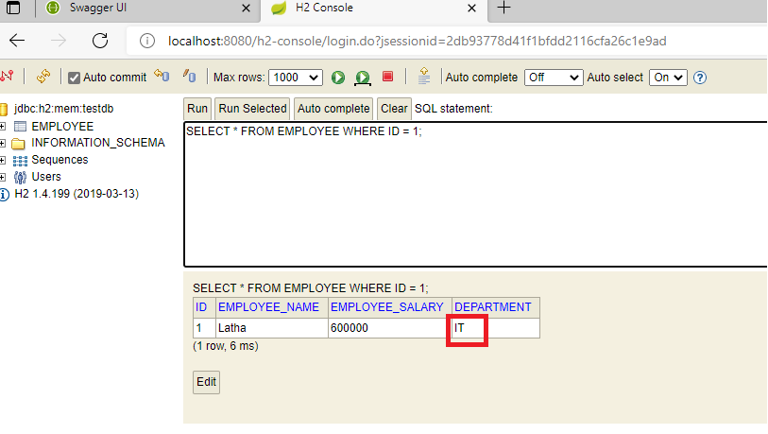

# Evidence for getPaginatedEmployees endpoint output through swagger

H2 Console :

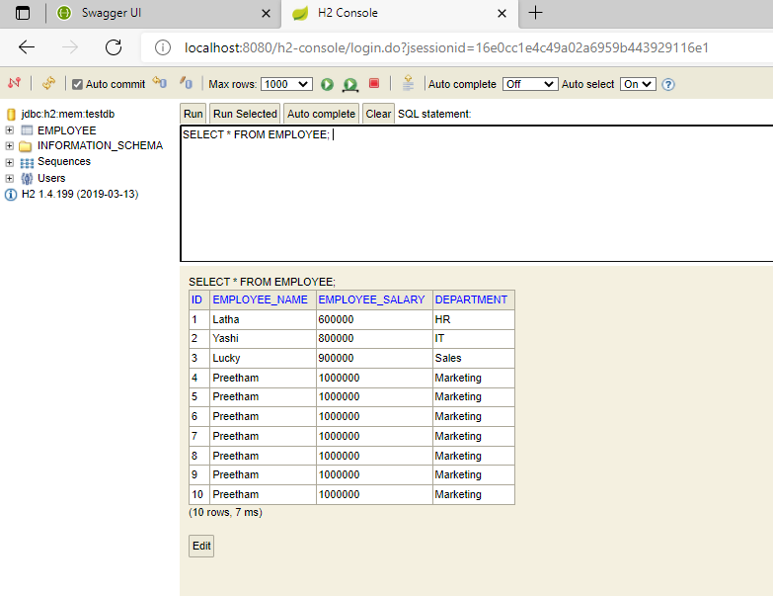

Swagger UI getPaginatedEmployees endpoint result:

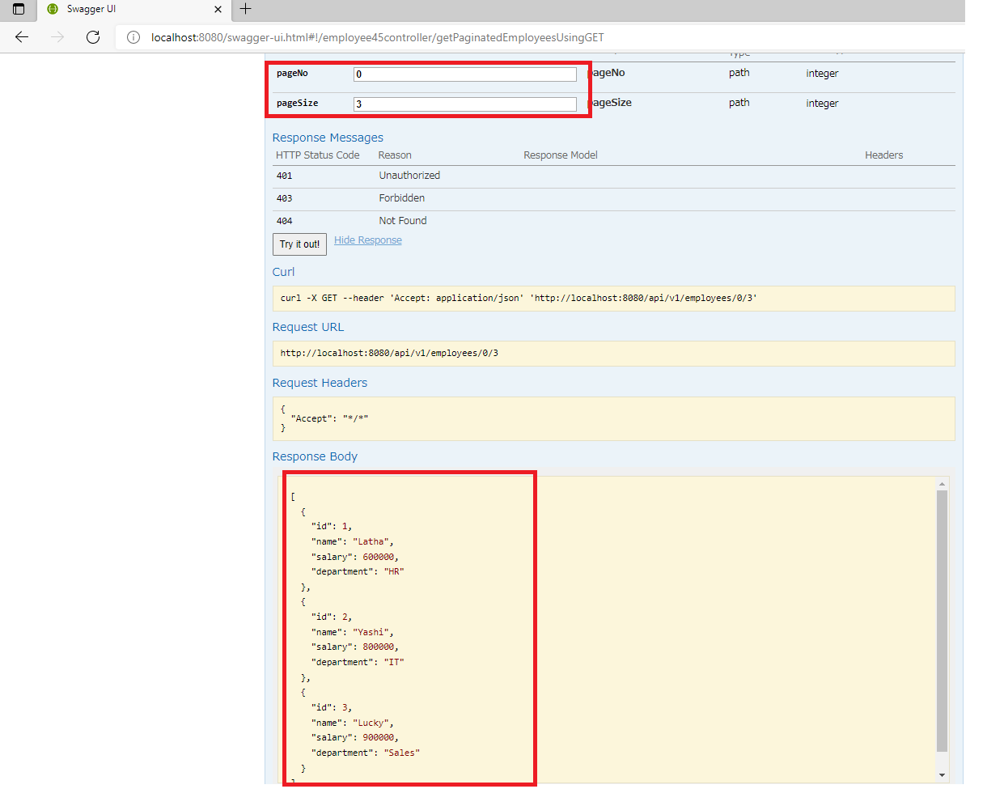

# Evidence for Employee Not Found in case of getEmployee endpoint

H2 Console :



Swagger UI getEmployee endpoint result after trying to get employee 14 :

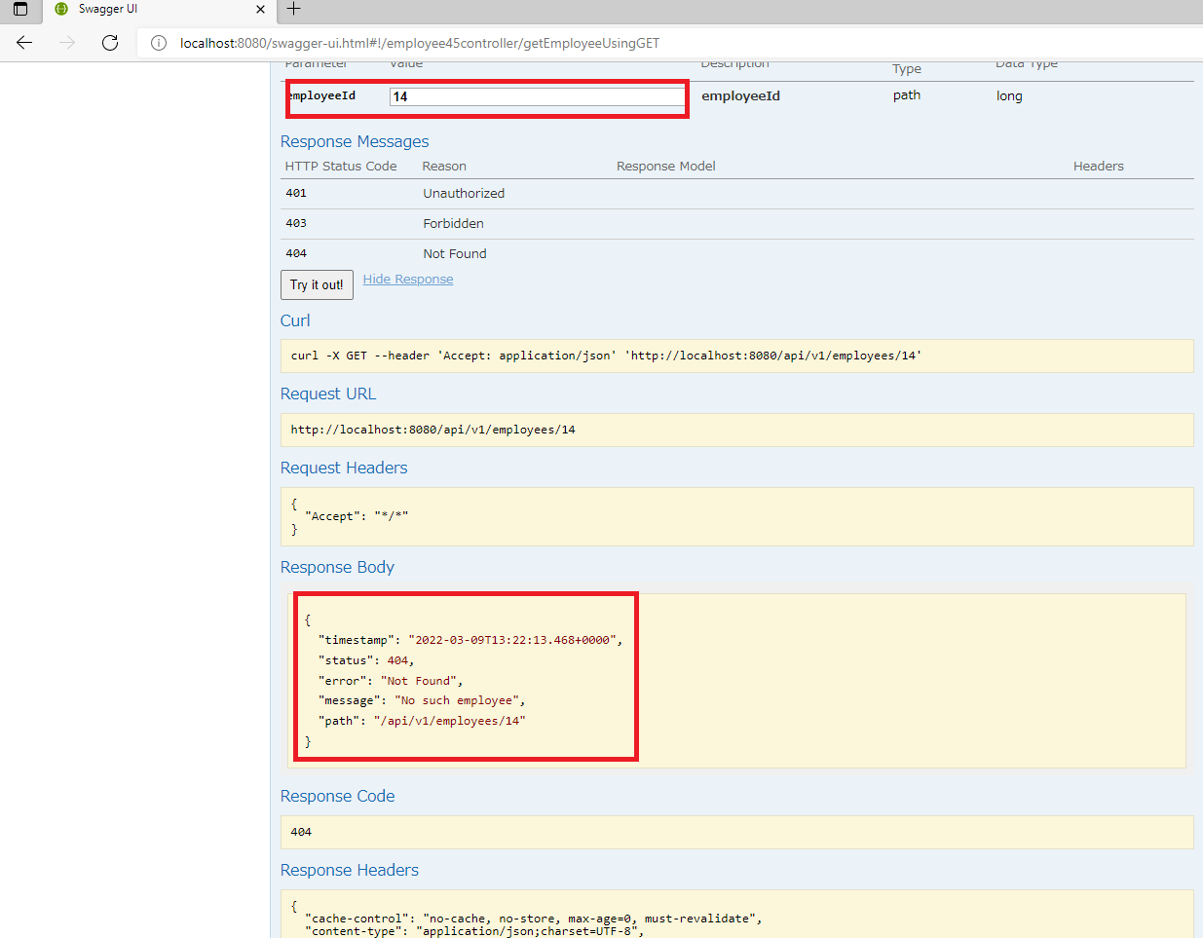

# Evidence for Employee Not Found in case of deleteEmployee endpoin

H2 Console :



Swagger UI deleteEmployee endpoint result after trying to delete employee 14 :

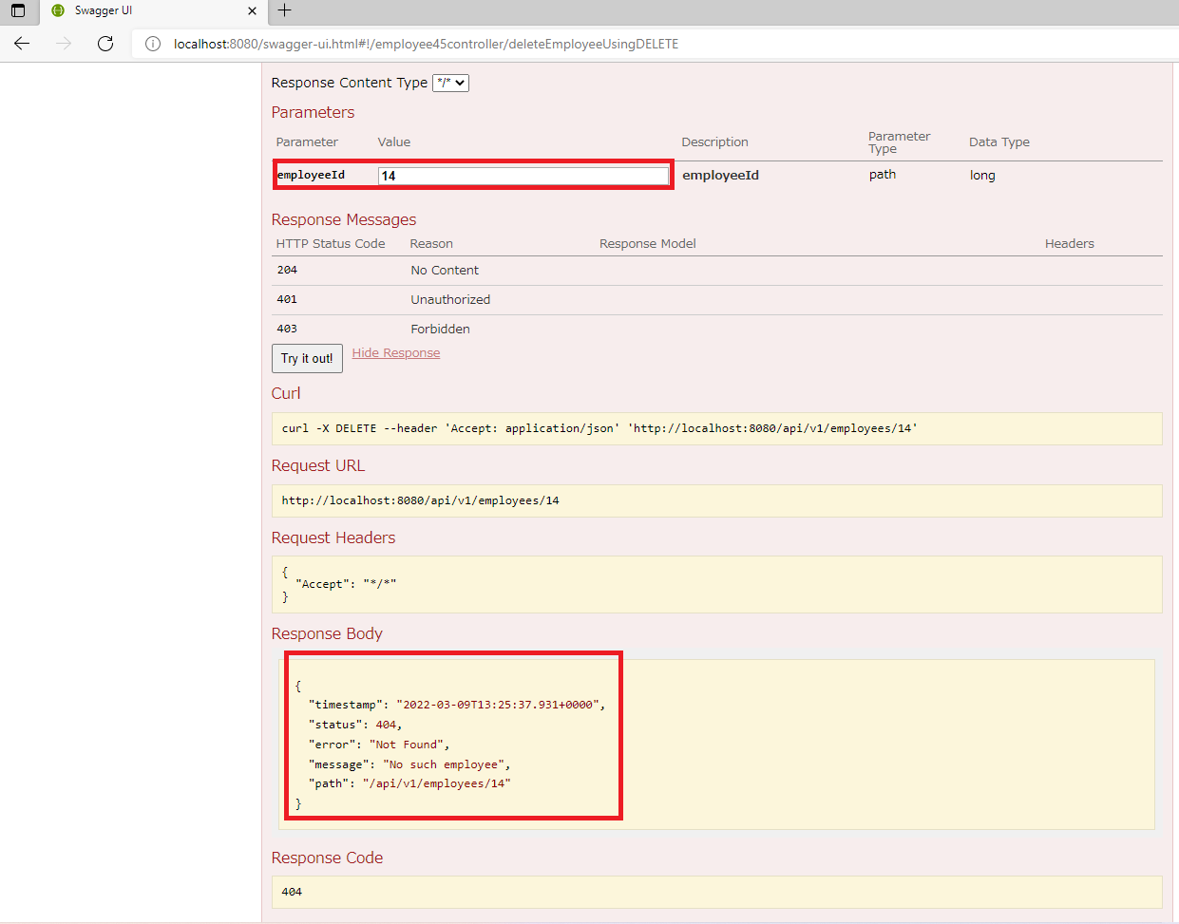

# Evidence for Employee Not Found in case of updateEmployee endpoint

H2 Console :



Swagger UI updateEmployee endpoint result after trying to update employee 14 :

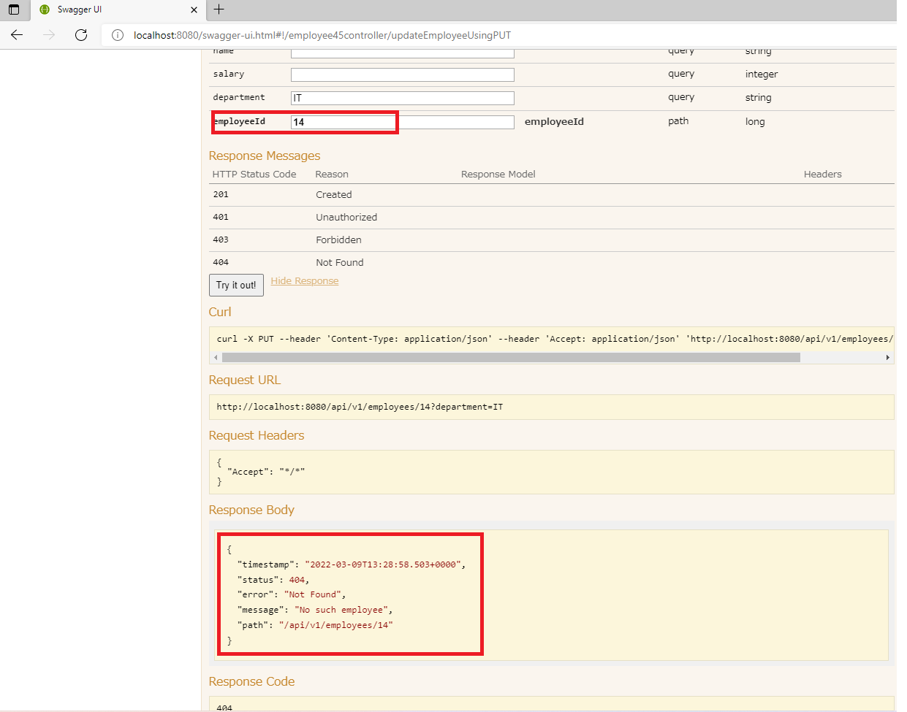

# Evidence for Caching

Swagger UI getEmployees endpoint access for the first time :

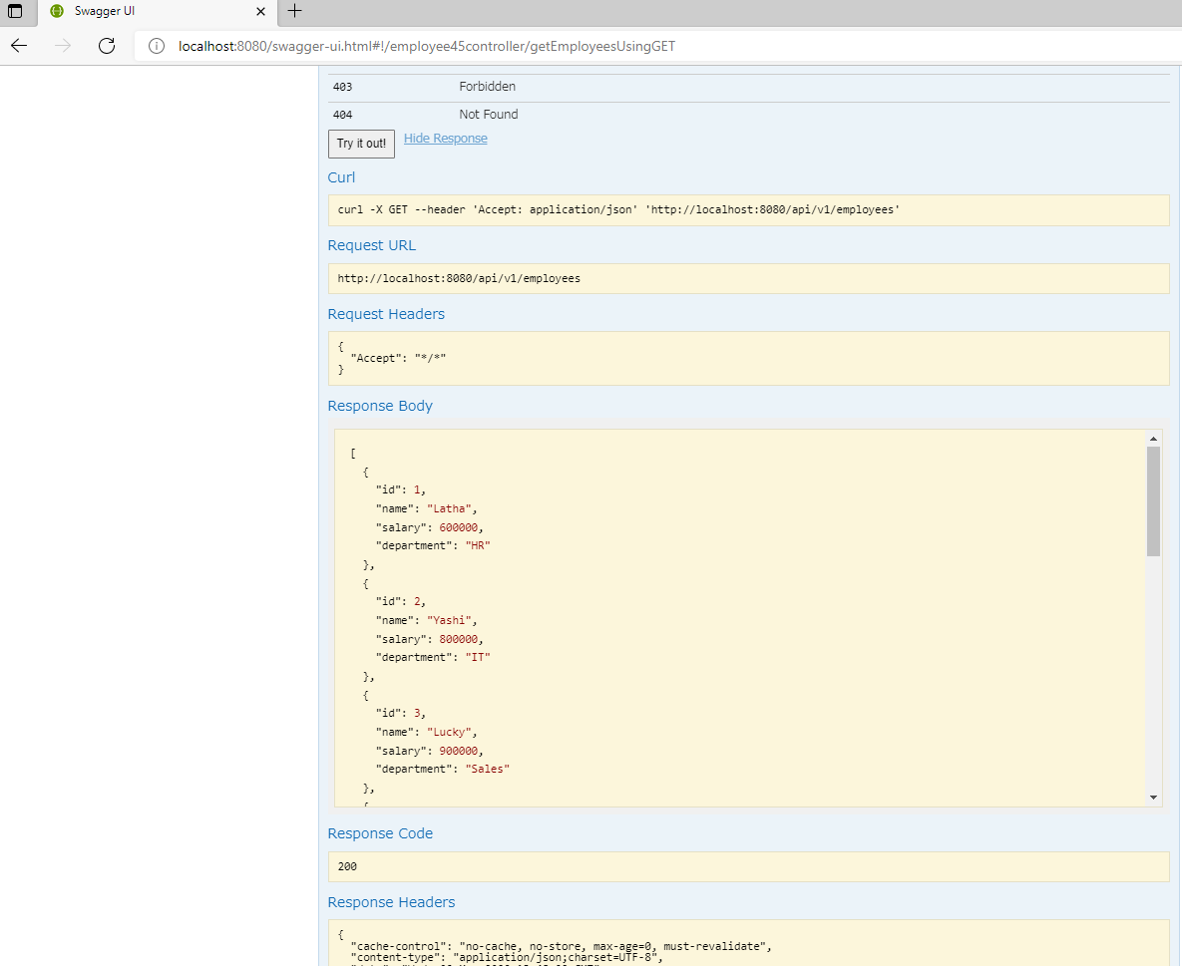

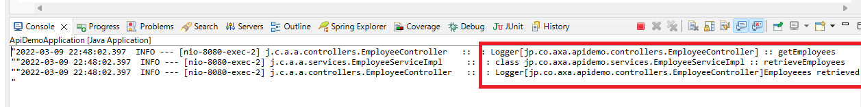

There is a call to service layer as shown in the log

Swagger UI getEmployee endpoint access for the first time :

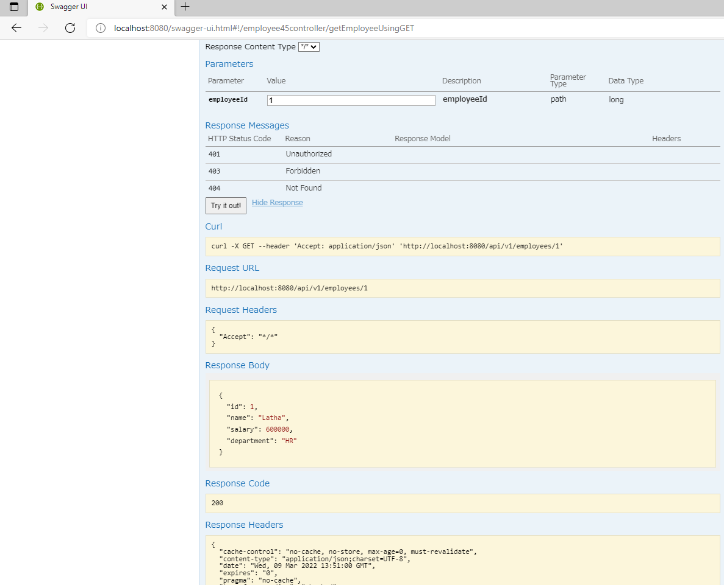

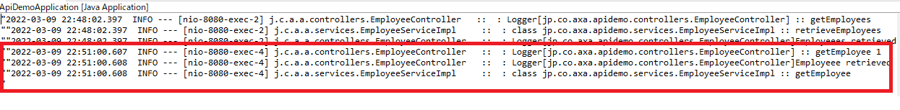

There is a call to service layer as shown in the log

Swagger UI getPaginatedEmployees endpoint access for the first time :

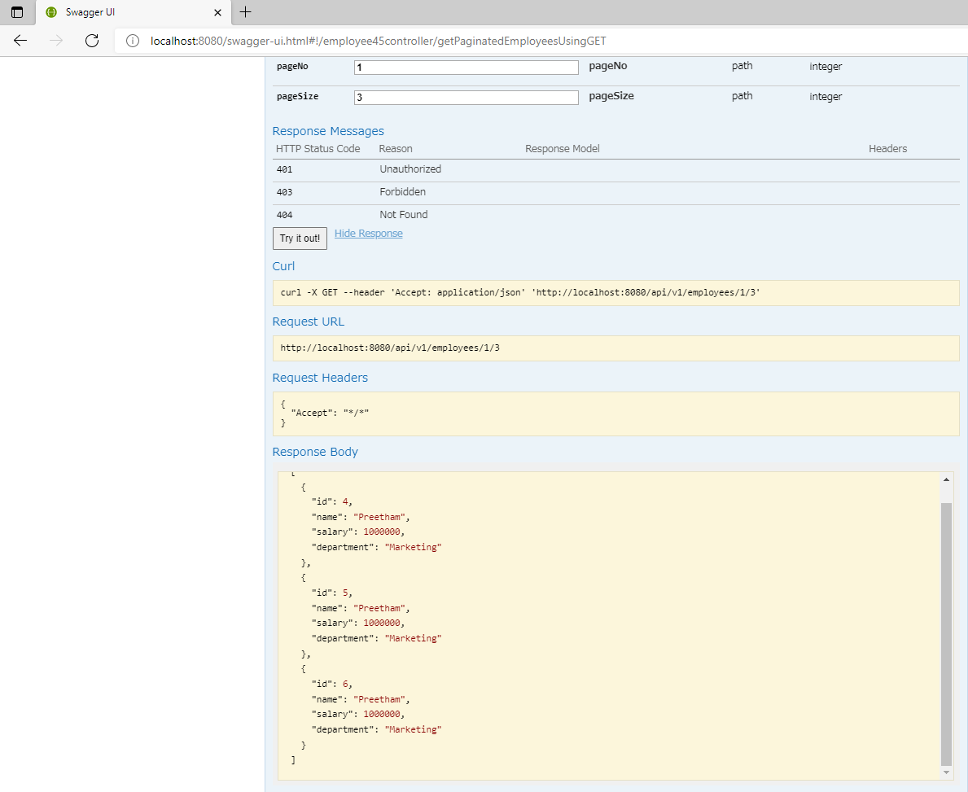

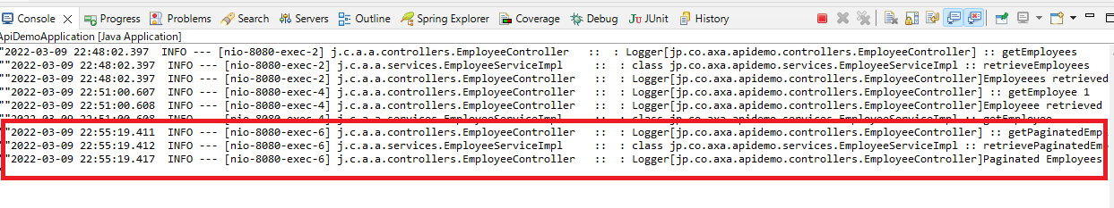

There is a call to service layer as shown in the log

Swagger UI getEmployees endpoint access for the second time :



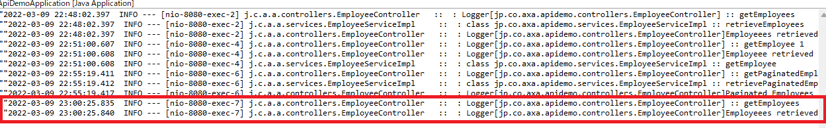

There is no call to service layer as shown in the log

Swagger UI getEmployee endpoint access for the second time :



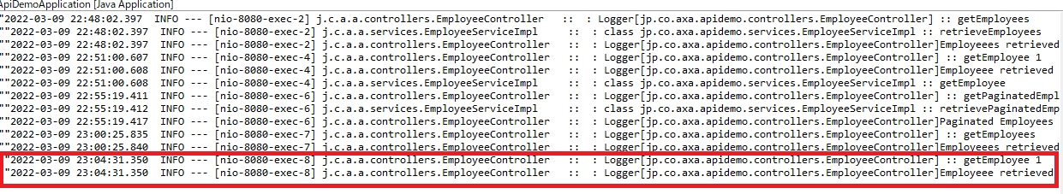

There is no call to service layer as shown in the log

Swagger UI getPaginatedEmployees endpoint access for the second time :



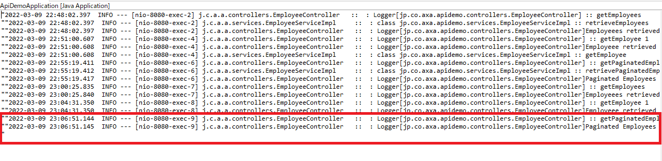

There is no call to service layer as shown in the log

Now Swagger UI deleteEmployee operation:

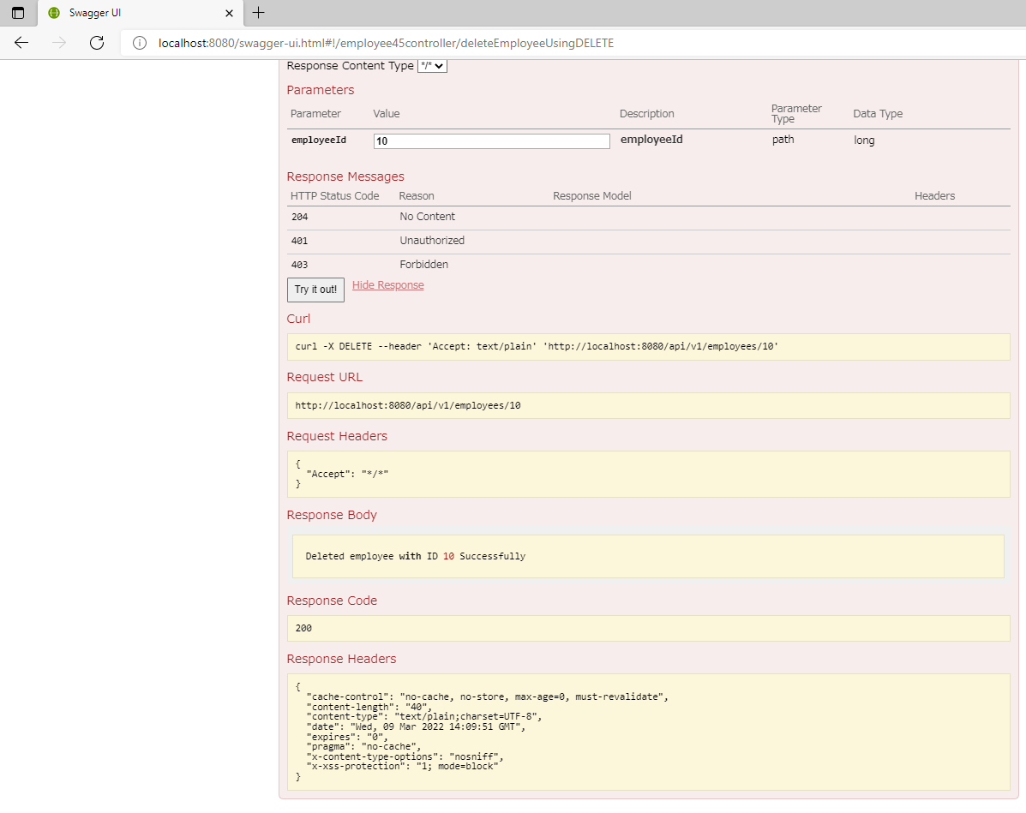

swagger UI getEmployees endpoint access after deleting employee:



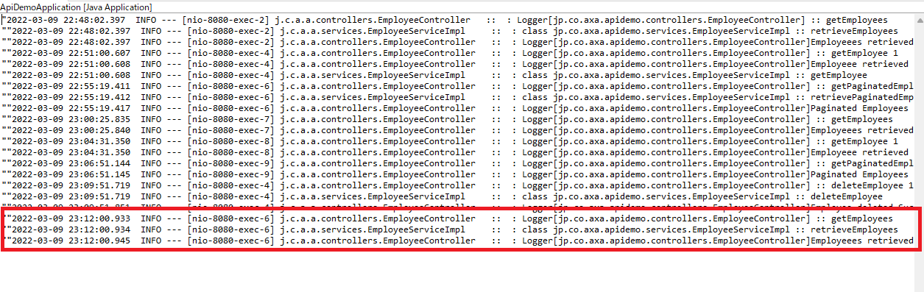

There is a call to service layer as shown in the log

Swagger UI getEmployee endpoint access after deleting employeess:



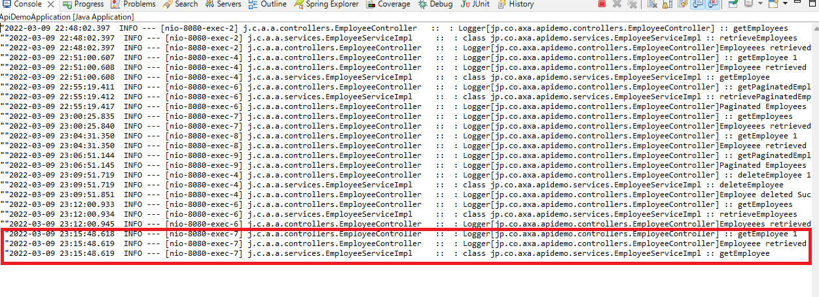There is a call to service layer as shown in the log

Swagger UI getPaginatedEmployees endpoint access after deleting employee :



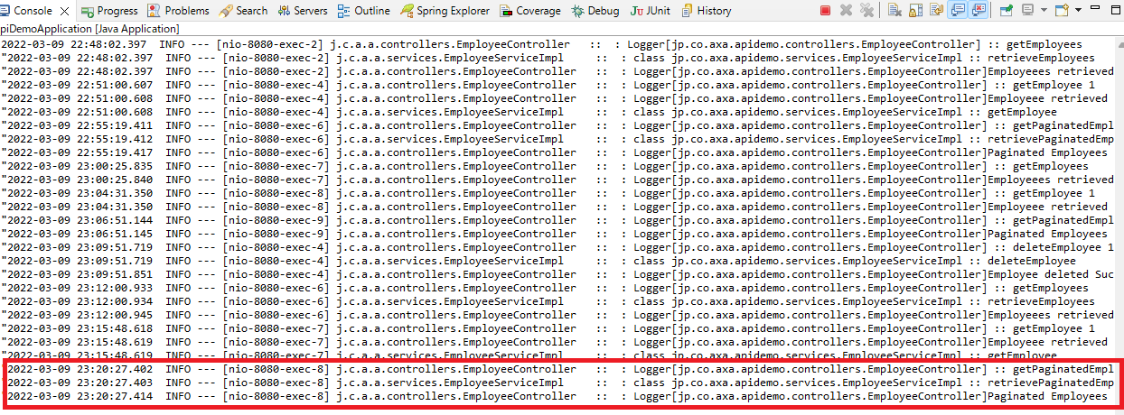

There is a call to service layer as shown in the log